Toko Trailers Ltd

**TANDEM AXLE CAR TRANSPORTER TRAILER**

**$783200 Inc GST**

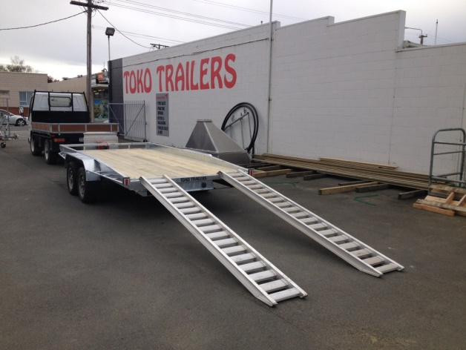 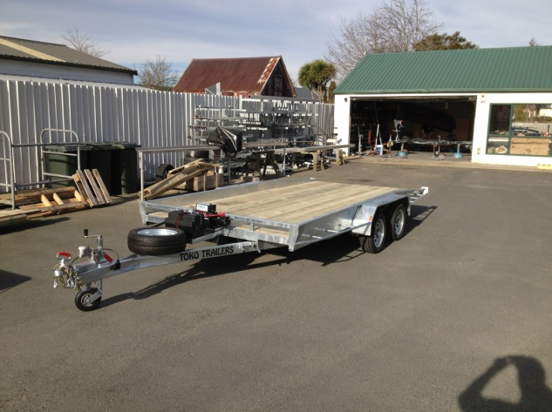

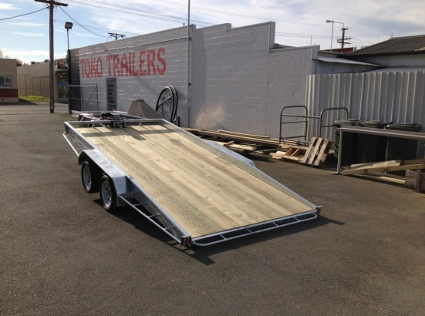**Features**:

* 4.5m x 2.0m Standard Deck Size
* Fully Hot Dip Galvanised
* Tandem Springs
* Tilting Trailer option available
* 195/50 13 H/D Low Profile Tyres
* Jockey Wheel
* 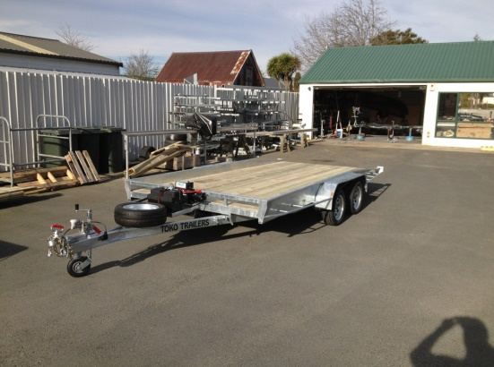LED Lights
* GVM: 2000kg
* GVM: 2500kg (with brakes)

**Extras**:

* Hydraulic Tilt - $2574.00
* Hydraulic Brakes - $1831.00

*\* All Pricing is inclusive of GST and subject to change without notice.*

**97 Union Street, Milton Ph: (03) 417-8727**

**www.tokotrailers.co.nz tokotrailers@xtra.co.nz**

**97 Union Street, Milton Ph: (03) 417-8727**

**www.tokotrailers.co.nz tokotrailers@xtra.co.nx**